January – February 2012

It is hard to believe we are already in 2012. As time goes rushing by, we are reminded to count our days and redeem the time. We are excited for what the Lord has in store for our family and ministry in 2012.

In December I was able to make a 10 day trip back to Argentina to visit the ministry. I was very encouraged to be a part of the Bible College graduation with four new graduates. We are excited to be preparing for 1st semester 2012 and looking forward to a great new group of students.

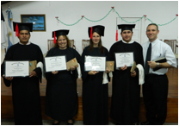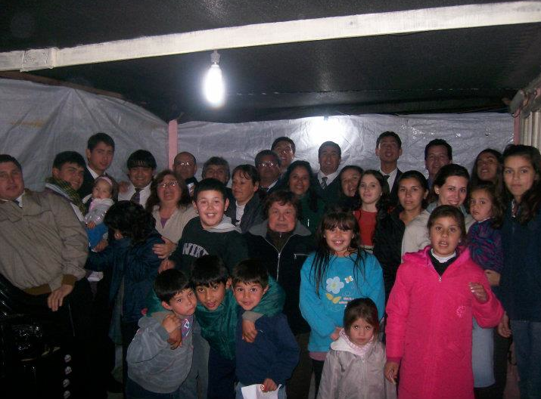
Graduates of Macedonia Baptist College Hope Baptist Church (newest church)

In the month of December the Lightouse Baptist Church was broken into and the majority of the radio equipment was stolen. Please pray this can be taken care of so we can soon be back on the air preaching the Gospel.

The newest church, Hope Baptist Church, is doing great and Pastor Hugo is really being used of the Lord. Please help us pray they can make some more payments on the land so that they can begin to build on the new land.

February is a special month for our family. Our son is going to be born in February and we ask you to remember my wife and the baby’s health.

We want to tell you of a few opportunities for the end of 2012 or 2013
- Your church group could come visit Argentina

- We are praying that one or two single girls could come help my wife with the schooling of our children.

- A team of builders visit Argentina to help with building projects in the churches.

Here to Serve,
Jeff and Mindy Bush and family

