January 2013

We finished the year with great and exciting blessings. Allow me to share a little of what God is doing in our lives as well as with Vision Baptist Missions. Within the last few months God has allowed 4 new missionary families to join our missionary family. In January some of the families currently on deputation will be leaving for the field. We at Vision Baptist Missions are anticipating even greater things in 2013!

Recently our 3rd daughter, Johanna, spoke with us about her need of being saved and afterwards made a profession of faith. She will be baptized soon at our home church and we are thankful that our three oldest daughters have placed their trust in Christ.

Every December Vision Baptist Missions holds a missions emphasis Summit in Gatlinburg, TN. Our home church and other churches come together with many missionaries from all over to challenge young people in the area of world missions. This year it will be held December 31st thru January 2nd and we already have over 300 registered. Please pray that the Holy Spirit makes hearts tender to become involved in what God is doing world-wide.

In December I had the privilege to visit Argentina, where my family and I spent 8 wonderful years as missionaries. They invited me to preach anniversary services for 2 of the churches, preach in the Bible college, preach on the radio and preach in the other churches. My heart was overflowing as I saw a great group of young people preparing for God’s service in the Bible college, many new people saved, all 4 churches growing and hearing some great testimonies. I am attaching some pictures so you can see one of the anniversary services (with 345 in attendance) and a group of students at the Bible college.
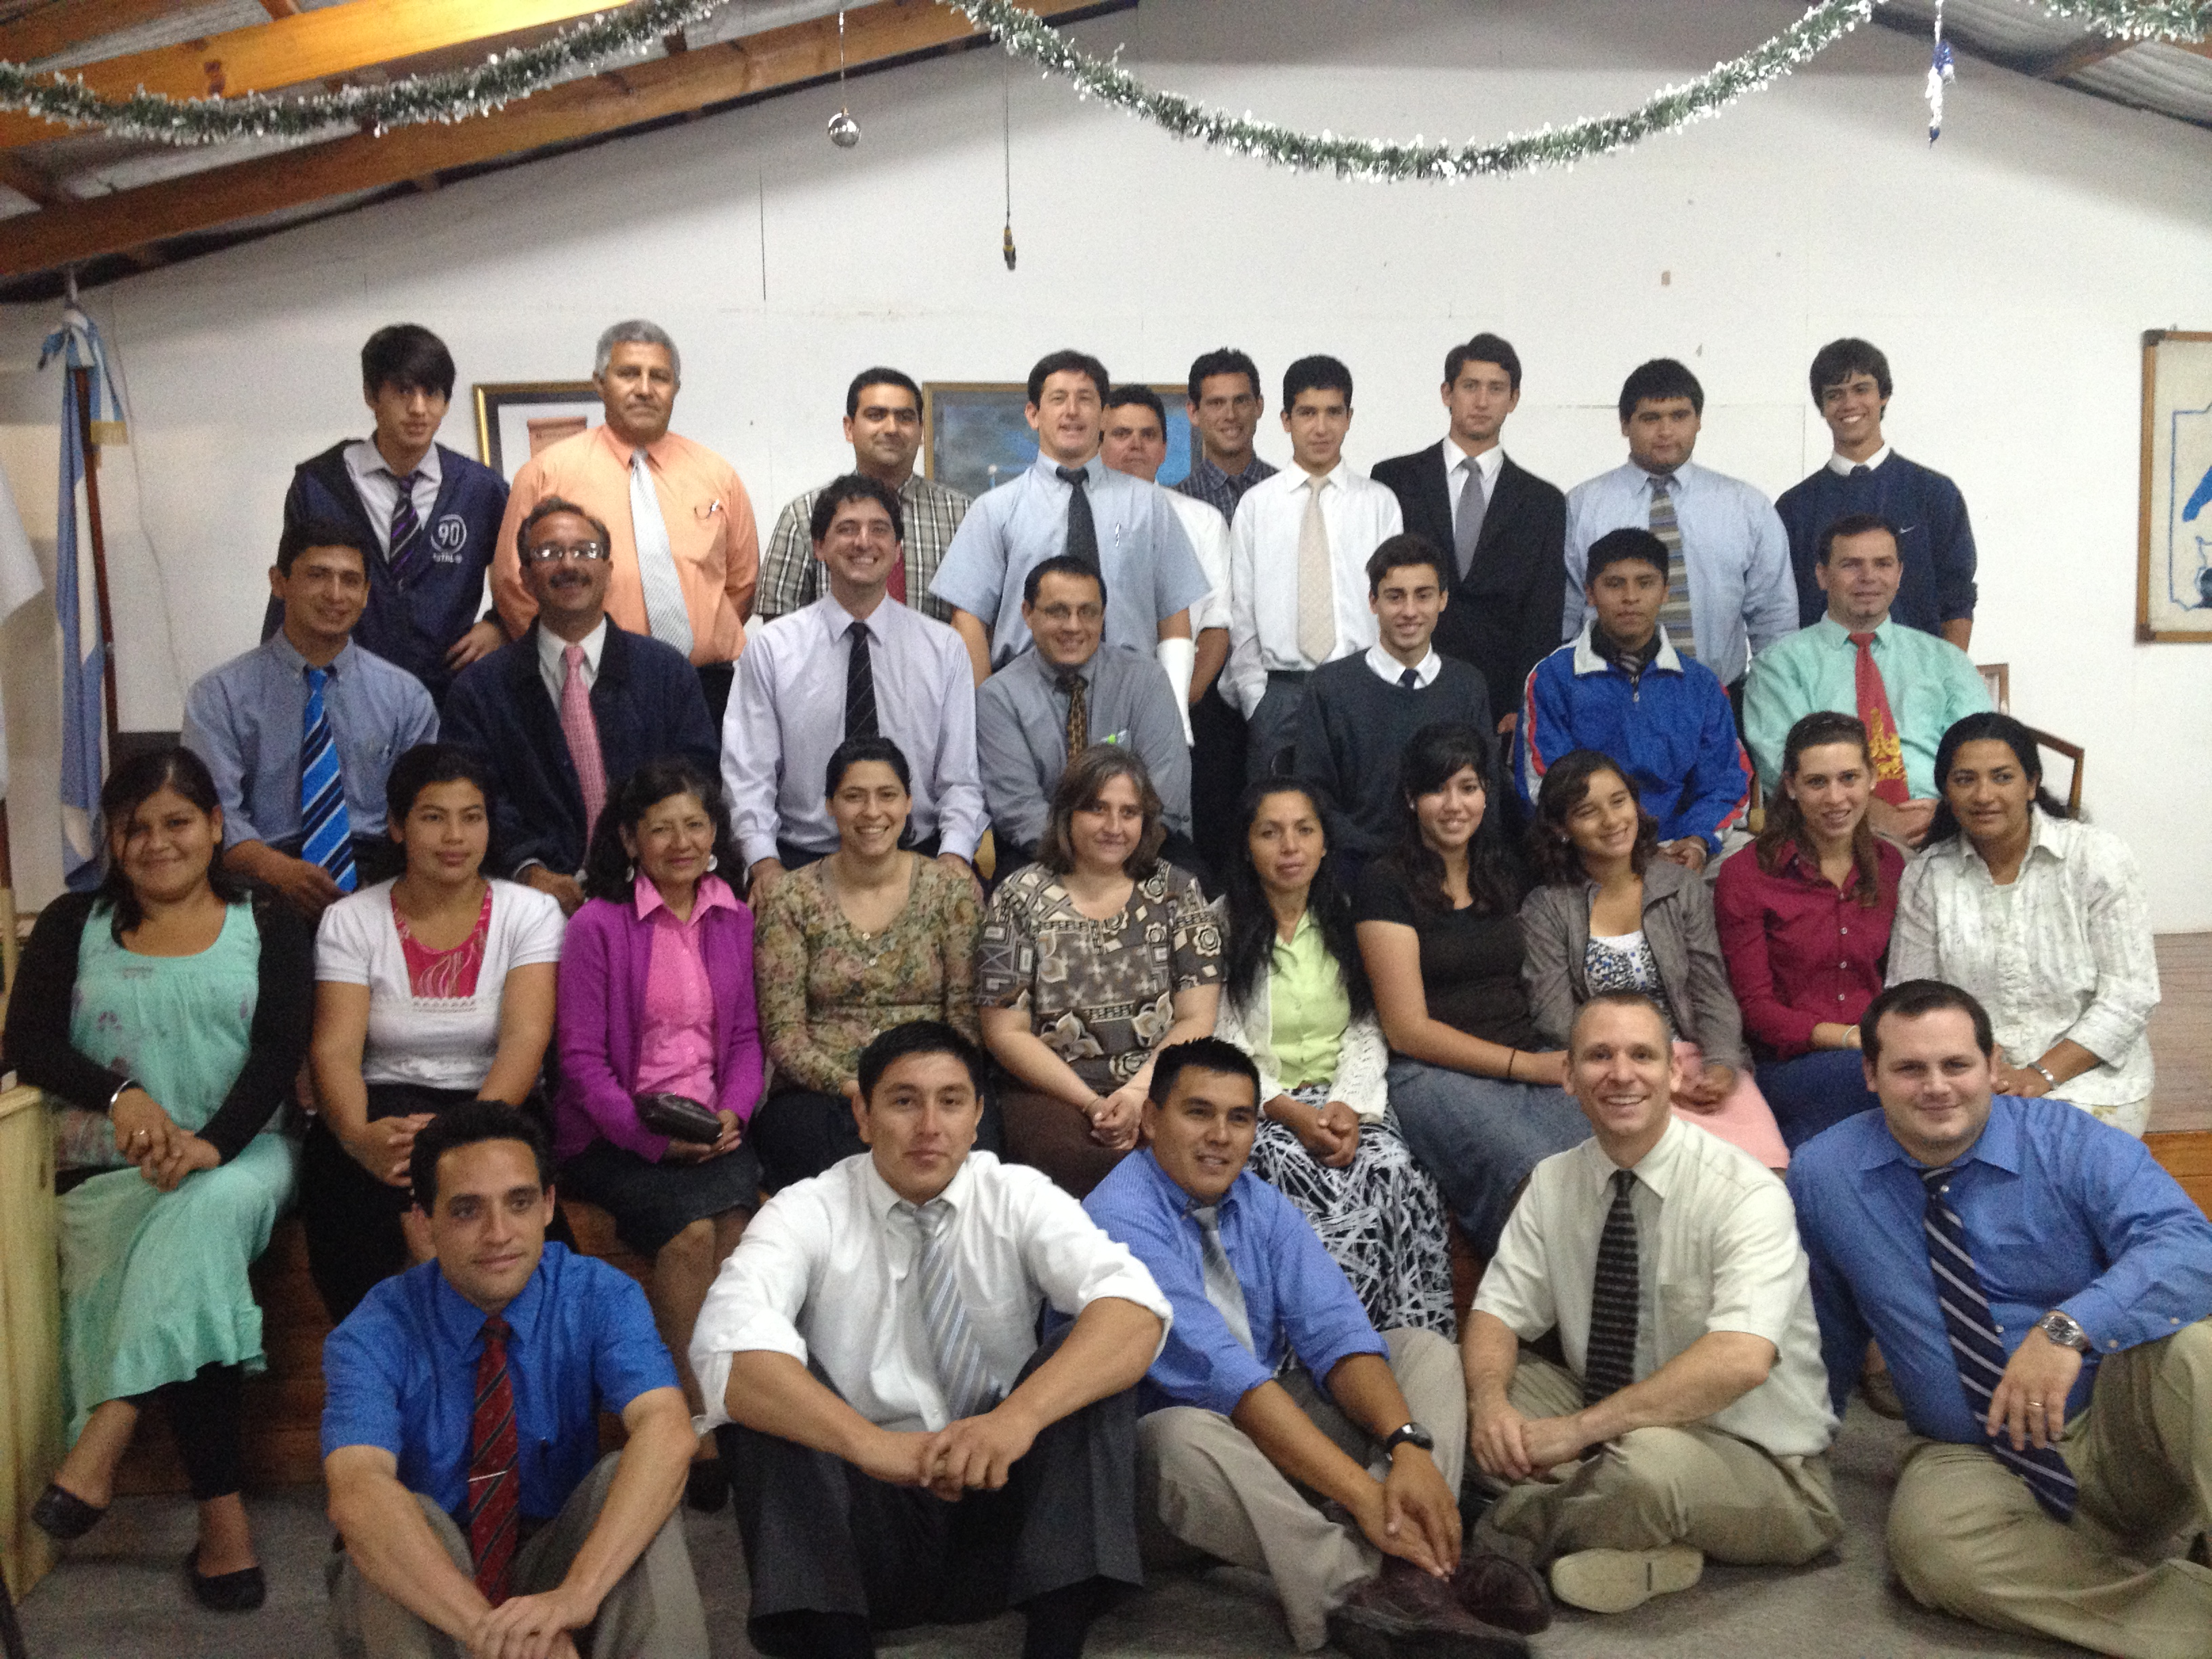
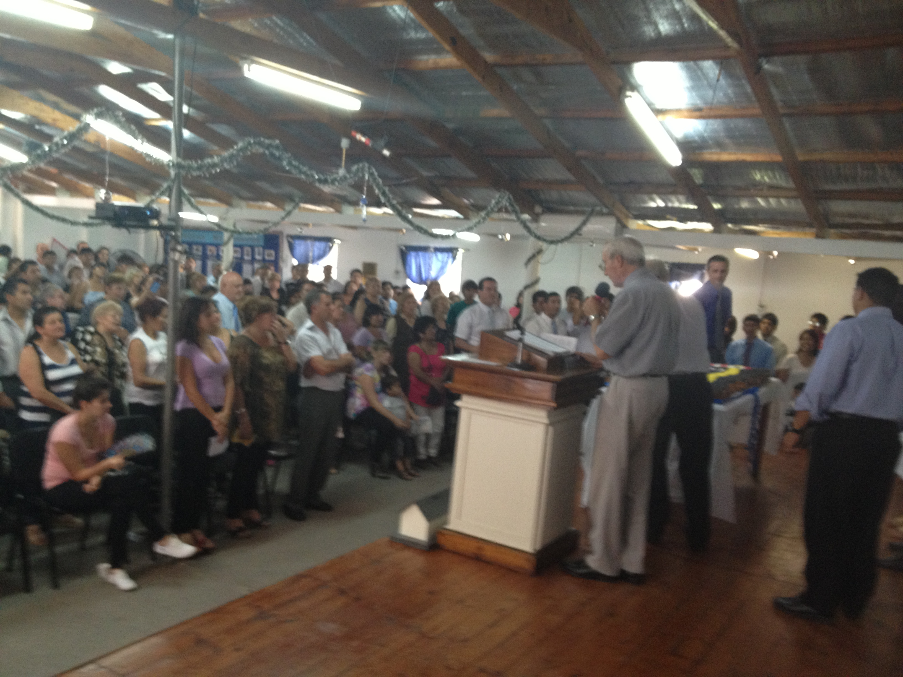

Here to Serve,
Jeff and Mindy Bush and family
www.visionbaptistmissions.com
770-362-3795

